**Homework 4 -- due Friday 29/1/2016, 23:59:59**

**Mobile Robot Soccer**  
  
In mobile robot soccer, following the real world setup, each team of collaborative robots uses a strategy to move in the field and score in the opponent's post. Each robot in the team moves on a given trajectory in a timely and precise manner to reach a scoring position. In this problem you should implement a fuzzy controller to ensure that the reference trajectory imposed by the strategy is tracked by a single robot with minimal error (Figure 1).  
  
  
                  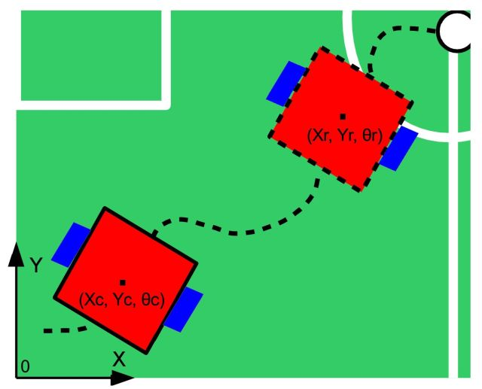  
**Figure 1**

**Problem 1:** [Membership Functions](http://ci.nst.ei.tum.de/homework/team/websubmit.php?cid=39&problem=41&showcode=1) (30p)  
  
In this problem you compute the membership values of the two inputs in the fuzzy controller of the robot. The inputs are the errors (pose error ***de*** and heading error ***θe***) between the reference position of the robot and the current position estimated by the sensors. The membership functions and error expressions are depicted in Figure 2.  
  
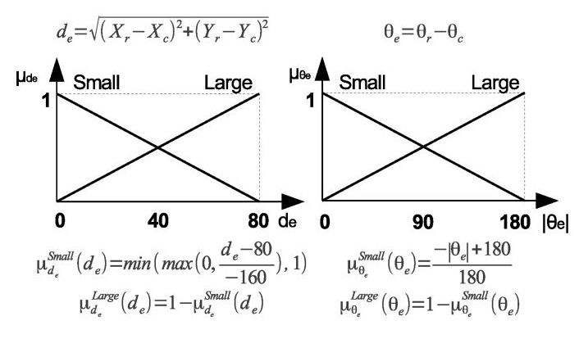  
**Figure 2**

**The inputs** are the reference and current trajectories of the robot are given as a sequence of coordinates in the 2D plane of the field (*Xr, Yr, θr, Xc, Yc, θc*) with less than 1000 entries in length.

**The output** should be a sequence of 4 values ***(μSmallde, μLargede , μSmallθe, μLargeθe)***, the same length as the input sequen

|  |  |  |
| --- | --- | --- |
| **Example Input** | **Visualization** | **Required Output** |
| [testInput41A.txt](http://ci.nst.ei.tum.de/ci_ws2015/homework/hw4/testInput41A.txt) | [image41A](http://ci.nst.ei.tum.de/ci_ws2015/homework/hw4/image41A.jpg) "click" for a large view | [testOutput41A.txt](http://ci.nst.ei.tum.de/ci_ws2015/homework/hw4/testOutput41A.txt) |
| [testInput41B.txt](http://ci.nst.ei.tum.de/ci_ws2015/homework/hw4/testInput41B.txt) | [image41B](http://ci.nst.ei.tum.de/ci_ws2015/homework/hw4/image41B.jpg) "click" for a large view | [testOutput41B.txt](http://ci.nst.ei.tum.de/ci_ws2015/homework/hw4/testOutput41B.txt) |

**Problem 2:** [Fuzzy Computation of Control Signals](http://ci.nst.ei.tum.de/homework/team/websubmit.php?cid=39&problem=42&showcode=1) (42p)  
  
In this problem you will compute the value of the control signals (e.g. left and right wheel velocities, depicted on the left side in Figure 3) for which the robot tracks the reference trajectory. The fuzzy controller will be implemented given the rules in Figure 3 and MFs in Figure 2 (above).  
  
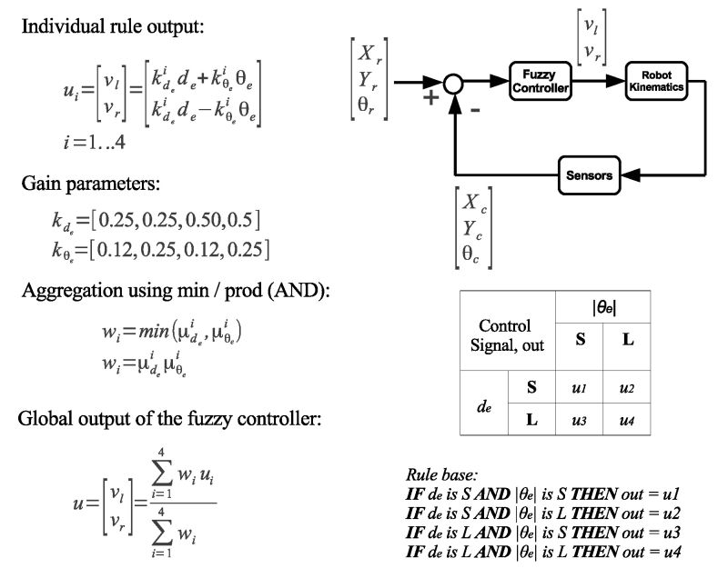  
  
**Figure 3  
  
The inputs** are the reference and current trajectories of the robot and are given as a sequence of coordinates in the 2D plane of the field (*Xr, Yr, θr, Xc, Yc, θc*) with less than 1000 entries in length.  
**The output** should be a sequence of 2 values (v*l, vr*) the same length as the input sequence.

|  |  |  |
| --- | --- | --- |
| **Example Input** | **Visualization** | **Required Output** |
| [testInput42A.txt](http://ci.nst.ei.tum.de/ci_ws2015/homework/hw4/testInput42A.txt) | [image42A](http://ci.nst.ei.tum.de/ci_ws2015/homework/hw4/image42A.jpg) "click" for a large view | [testOutput42A.txt](http://ci.nst.ei.tum.de/ci_ws2015/homework/hw4/testOutput42A.txt) |
| [testInput42B.txt](http://ci.nst.ei.tum.de/ci_ws2015/homework/hw4/testInput42B.txt) | [image42B](http://ci.nst.ei.tum.de/ci_ws2015/homework/hw4/image42B.jpg) "click" for a large view | [testOutput42B.txt](http://ci.nst.ei.tum.de/ci_ws2015/homework/hw4/testOutput42B.txt) |

**Problem 3:** [Fuzzy Control Loop](http://ci.nst.ei.tum.de/homework/team/websubmit.php?cid=39&problem=43&showcode=1) (48p)  
  
In this problem you will implement the full fuzzy control loop (Figure 4, bottom) for trajectory tracking. Given the fuzzy rules, MFs and robot kinematics (Figure 4, top) compute the control signal to track the reference trajectory. In our application, the distance between the robot's wheels is **D=0.16** (so 16 cm), and the initial position of the robot corresponds to the initial point of the reference trajectory, **Xc(0) = Xr(0)**, **Yc(0) = Yr(0)** and **θc(0) = θr(0)**.

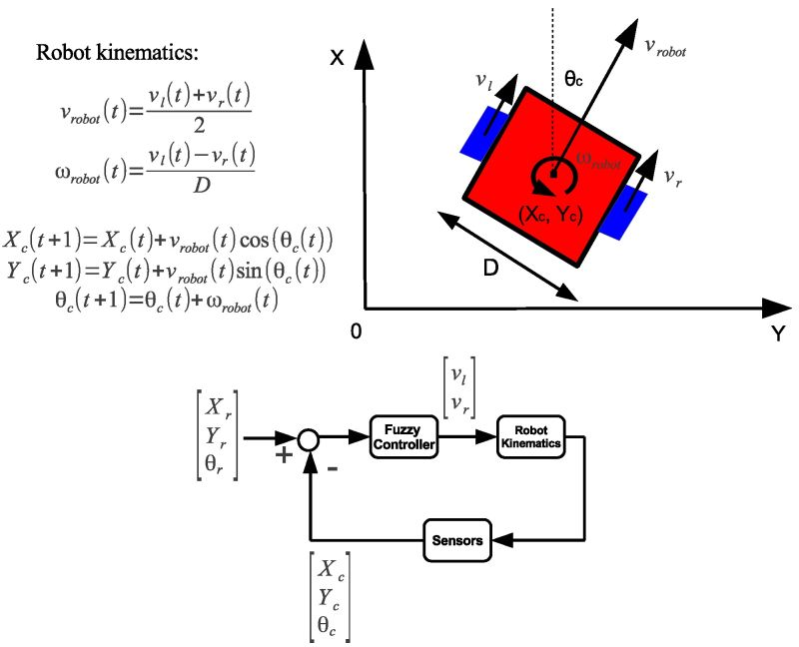

**Figure 4**

**The input** is the robot's reference trajectory given as a sequence of coordinates in the 2D plane of the field (*Xr, Yr, θr*) with less than 1000 entries in length.

**The output** should be a sequence of coordinates in the 2D plane of the field (*Xc, Yc, θc*) the same length as the input sequence.

|  |  |  |
| --- | --- | --- |
| **Example Input** | **Visualization** | **Required Output (one possible solution)** |
| [testInput43A.txt](http://ci.nst.ei.tum.de/ci_ws2015/homework/hw4/testInput43A.txt) | [image43A](http://ci.nst.ei.tum.de/ci_ws2015/homework/hw4/image43A.jpg) "click" for a large view | [testOutput43A.txt](http://ci.nst.ei.tum.de/ci_ws2015/homework/hw4/testOutput43A.txt) |
| [testInput43B.txt](http://ci.nst.ei.tum.de/ci_ws2015/homework/hw4/testInput43B.txt) | [image43B](http://ci.nst.ei.tum.de/ci_ws2015/homework/hw4/image43B.jpg) "click" for a large view | [testOutput43B.txt](http://ci.nst.ei.tum.de/ci_ws2015/homework/hw4/testOutput43B.txt) |